* **Sequence Diagram:**
  + Shows the interaction between the user, frontend, server (Raspberry Pi), AWS Chime SDK, IAM, and optional AWS Lambda functions.
  + Details each step of the process, from setting up the meeting to joining and streaming video/audio.
* **sequenceDiagram**
* autonumber
* participant User as Mobile Browser
* participant Frontend as HTML/JS Client
* participant RaspberryPi as Raspberry Pi Server
* participant ChimeSDK as AWS Chime SDK
* participant IAM as AWS IAM
* participant Lambda as AWS Lambda (Optional)
* User**->>**Frontend: Open index.html
* Frontend**->>**RaspberryPi: Send Request to /createMeeting
* RaspberryPi**->>**IAM: Authenticate Request (AWS Credentials)
* IAM**-->>**RaspberryPi: Authentication Success
* RaspberryPi**->>**ChimeSDK: CreateMeetingCommand
* ChimeSDK**-->>**RaspberryPi: Meeting Details
* RaspberryPi**-->>**Frontend: Meeting Created (JSON)
* Frontend**->>**RaspberryPi: Send Request to /createAttendee with MeetingId and UserId
* RaspberryPi**->>**ChimeSDK: CreateAttendeeCommand with MeetingId and UserId
* ChimeSDK**-->>**RaspberryPi: Attendee Details
* RaspberryPi**-->>**Frontend: Attendee Created (JSON)
* Frontend**-->>**User: Display Meeting and Attendee Info
* User**->>**Frontend: Join Meeting
* Frontend**->>**ChimeSDK: Connect to Meeting with Attendee Credentials
* ChimeSDK**-->>**Frontend: Streaming Audio/Video
* Frontend**-->>**User: Show Meeting Audio/Video
* **alt** Optional Server-Side Logic
* RaspberryPi**->>**Lambda: Invoke Lambda Function (e.g., manage meetings)
* Lambda**->>**ChimeSDK: Create/Manage Meeting or Attendee
* ChimeSDK**-->>**Lambda: Return Response
* Lambda**-->>**RaspberryPi: Response
* **end**

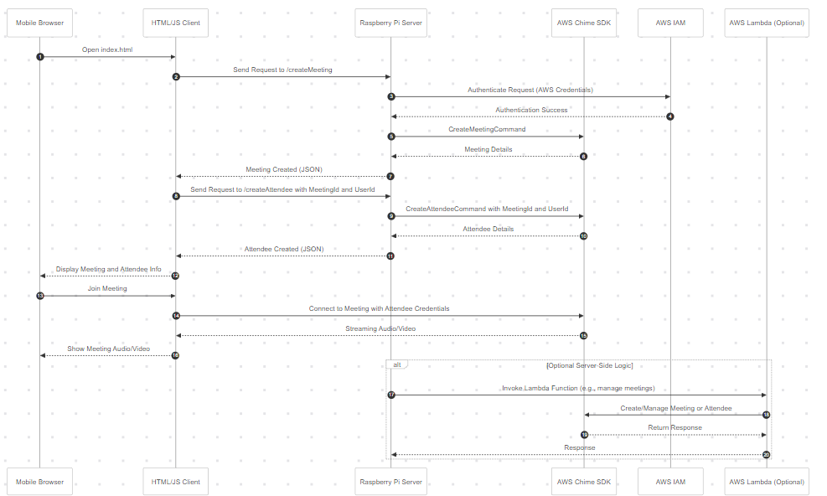

* **Flowchart:**
  + Provides a high-level overview of the entire setup and flow.
  + Includes the setup phases (AWS, Raspberry Pi), the meeting creation flow, the attendee creation process, and the final meeting connection and streaming phase.
* **flowchart** TB
* %% AWS Setup
* **subgraph** AWS_Setup [AWS Setup]
* B[Configure AWS Account] **-->** C[Create IAM Role with Chime SDK Permissions]
* **end**
* %% Raspberry Pi Setup
* **subgraph** RaspberryPi_Setup [Raspberry Pi Setup]
* D[Setup Raspberry Pi] **-->** E[Install Node.js and AWS CLI]
* E **-->** F[Configure AWS CLI with Credentials] **-->** G[Create Node.js Application]
* G **-->** H[Create server.js File] **-->** I[Run Node.js Server on Raspberry Pi]
* **end**
* %% Meeting Creation
* **subgraph** Meeting_Creation [Meeting Creation]
* K[User Opens index.html on Mobile Browser] **-->** L[Client Requests /createMeeting]
* L **-->** M[Raspberry Pi Authenticates with IAM] **-->** N[Raspberry Pi Sends CreateMeetingCommand to Chime SDK]
* N **-->** O[Chime SDK Creates Meeting] **-->** P[Raspberry Pi Responds with Meeting Details]
* **end**
* %% Attendee Creation
* **subgraph** Attendee_Creation [Attendee Creation]
* Q[Client Requests /createAttendee with MeetingId] **-->** R[Raspberry Pi Sends CreateAttendeeCommand to Chime SDK]
* R **-->** S[Chime SDK Creates Attendee] **-->** T[Raspberry Pi Responds with Attendee Details]
* **end**
* %% Meeting Connection
* **subgraph** Meeting_Connection [Meeting Connection]
* U[Client Connects to Chime SDK Meeting] **-->** V[Streaming Audio/Video to Mobile Browser]
* V **-->** W[Display Meeting on Mobile Browser]
* **end**
* A([Start]) **-->** AWS_Setup
* AWS_Setup **-->** RaspberryPi_Setup
* RaspberryPi_Setup **-->** Meeting_Creation
* Meeting_Creation **-->** Attendee_Creation
* Attendee_Creation **-->** Meeting_Connection
* Meeting_Connection **-->** X([End])

